IMPORTANT INFORMATION
PLEASE READ

Welcome to Vancouver! We are pleased to have you here, we love hosting guests from all over the world! Before you begin to enjoy this amazing city let’s start by going over a few important rules about our home and the building that it is in to make your stay pleasant and relaxing!

XX. Building / House Rules

XX. Apartment & Contact information

XX. Check-in Procedures
How to obtain keys
Access required to enter the building
Security policy

XX. Parking - Location & Direction

XX. Address

XX. Internet & Cable

XX. Amenities

XX. Garbage & Recycling

XX. Checkout Procedures

Building / House Rules (Recommended to also post in front door)

- No smoking is allowed in the entire building. This includes the balconies and the central courtyard.

- No objects of any kind are to be thrown off the balcony. A large fine and instant eviction will occur if anyone is found doing so.

- When exiting or entering the parking garage, you must wait until the gate is completely closed before leaving. (failure to wait will result in a charge)

- Excess noise/partying is not permitted. Please be quiet after 9pm.

- Please leave shoes at the front door, and clean up spills promptly, as the laminate floors stains and damages easily.

- Lights and heat turned off while they are not in use, as we are an environmentally conscious building.

- Make sure all faucets are shut off prior to leaving. If the faucets does not stop dripping or you see water on the floor please report this to your host right away.

- If anything does get damaged or lost, please kindly let us know prior to your departure.

- Please be mindful of what goes in the garburator, it can only handle coffee grounds, soft foods and egg shells. All else should go in the garbage.

- Our building is environmentally conscious. Please ensure that all recycling is sorted properly, and the remaining items thrown out in the garbage. Failure to do so will result in a fine. The garbage room is monitored by a video camera.

- The concierge is for the use of long term residents only. If you have any questions or concerns please contact us, your hosts directly.

Thank you so much! Have a wonderful day.
Your HOST. XXX.XXX.XXXX

Contact Information

If I can help you with anything during your stay please contact me Via Airbnb messenger or give me a call and will answer as soon as possible.

The concierge / security guards in the building is for the exclusive use of the residents only. Please reachout to us only and we will promptly reply any inquiries you have.

My Contact: JOHN WAYNE
604.XXX.XXXX
johnwayne@gmail123.com

2nd Contact JULIA WAYNE
778.XXX.XXXX
juliawayne@gmail123.com

____________________________________________________________________________

Apartment Information

Address: # XXXX - 689 Abbott Street
Vancouver, BC. V6B 0J2

Floor: XX

Parking: PX - XXX

Buzzer: XX??

Key Words: Next to Stadium-Chinatown Station
Next to Rogers Arena

Mail: Please note that the building will not collect any mail on your behalf.
If that is required please contact me directly to arrange.

Check-In Procedures

How to obtain Keys

Our check-in time is from 3pm onward from the day of your check-in. You will not be allow to check-in before that unless previously arranged.

Prior to arrival, via the Airbnb (short term rental sites) please let me know:
- Your arrival date
- Estimated time of arrival to the apartment
- Will you have cellular phone / wifi access once you are in the country
- Who we will be meeting.

OR

Please check your email for Key Pickup Code
- Key Pick up will be at XXX

>>> Instructions

>>> Instructions

>>> Instructions

The concierge is for the use of the long term residents only. If you have any questions or concerns please contact us (me) directly.

Parking

Examples in Espana

Parking is located at P3, stall #5XX
Entrance is located beside Blenz Coffee on Keefer Place
Use key fob to open the garage gates.

FINDING THE PARKING - Turn Left (if heading North on Abbott Street) or Right (if heading
South on Abbott Street) onto Keefer Place, Turn Left into the Impark Lot. Follow it around
the first bend and continue on until you get a ramp going down (on your right-hand side
opposite the parking garage exit) and it will be gate #5, proceed down the ramp and turn
right until you get to gate #6, go through the gate and turn right, go around the bend until
you reach a ramp going down to level P2, follow along the bend or bends until you get to
another ramp going down to P3, drive around the first bend and the spot will be on the right
#5XX.

**Please see picture of the parking garage fob below for your reference to which button to
press for opening the appropriate gate.**

VERY IMPORTANT: Please wait for the gate to close behind before proceeding as the strata is
very stringent on keeping the building safe and fines may be charged.

If you have any trouble finding the parking please contact me via airbnb messaging (fastest
response) or text/phone at (XXX)XXX-XXXX. Do not contact the concierge.

_____________________________

More Examples Below

Parking is located on Gate 2, Level 1 #1X
Entrance is located beside Blenz Coffee on Keefer Pl.
Use key fob to open the garage gates.

FINDING THE PARKING - The parking lot is located between Blenz Coffee shop on the
corner of Abbott street & 188 Keefer Place. Enter the parking lot from Keefer Place and
drive down. When you see Gate 2, press buttons on the fob remote to open gate. Drive in
and make a first left uphill and second left downhill. The parking spot #1X is on your right
hand side.

_____________________________

Parking is located on Gate 2, L1 Stall #9X
Entrance is located beside Blenz Coffee on Keefer Pl.
Use key fob to open the garage gates.
FINDING THE PARKING - Parking lot is located between Blenz Coffee shop on the corner
of Abbott Street & 188 Keefer Place. Enter the parking lot on your left from Keefer Place.
After 100 meters on your right there will be a gate labelled "Gate 2". Enter through the gate
making sure it closes behind you and go up the hill, take a left and the space will be directly
in front of you, # 9X

____________________________

Parking is located on P2 Stall #31X
Entrance is located beside Blenz Coffee on Keefer Place
Use key fob to open the garage gates.

FINDING THE PARKING - Turn left (if heading north on Abbott Street) or Right (if heading South of Abbott Street) onto Keefer Place, Turn Left into the Impark Lot (besides the Blenz coffee shop.) Follow it around the first bend and continue on until you get to a ramp going down (on your right-hand side opposite the parking garage exit) proceed down the ramp and turn right, go until you get to gate #4, go through the gage, make sure to wait for the gate to close behind you, please park in stall #31X to your right. You can use the door in photo to the right to access the elevator to your unit.

Rules to accessing the building (Security Policy)

Rule #1

When going through any doors or gates from the exterior, please make sure that it closes fully before proceeding. Failure to do so will put the building at risk and you will be fined for not waiting for the doors to close.

Rule #2

When going through the parking garage, if there is a car waiting behind you, please make sure the gate closes before proceeding. Ensure that the gate starts to close, and make sure that the vehicle behind you has a security fob.

Rule #3

When going through the entrance doors, please ensure that anyone who is entering the doors also has a fob as well. If they do not have a fob, please make sure they stay outside and that the door closes behind you.

Rule #4

Security is everyone's responsibility including yours. Please ensure that the building is safe for everyone.

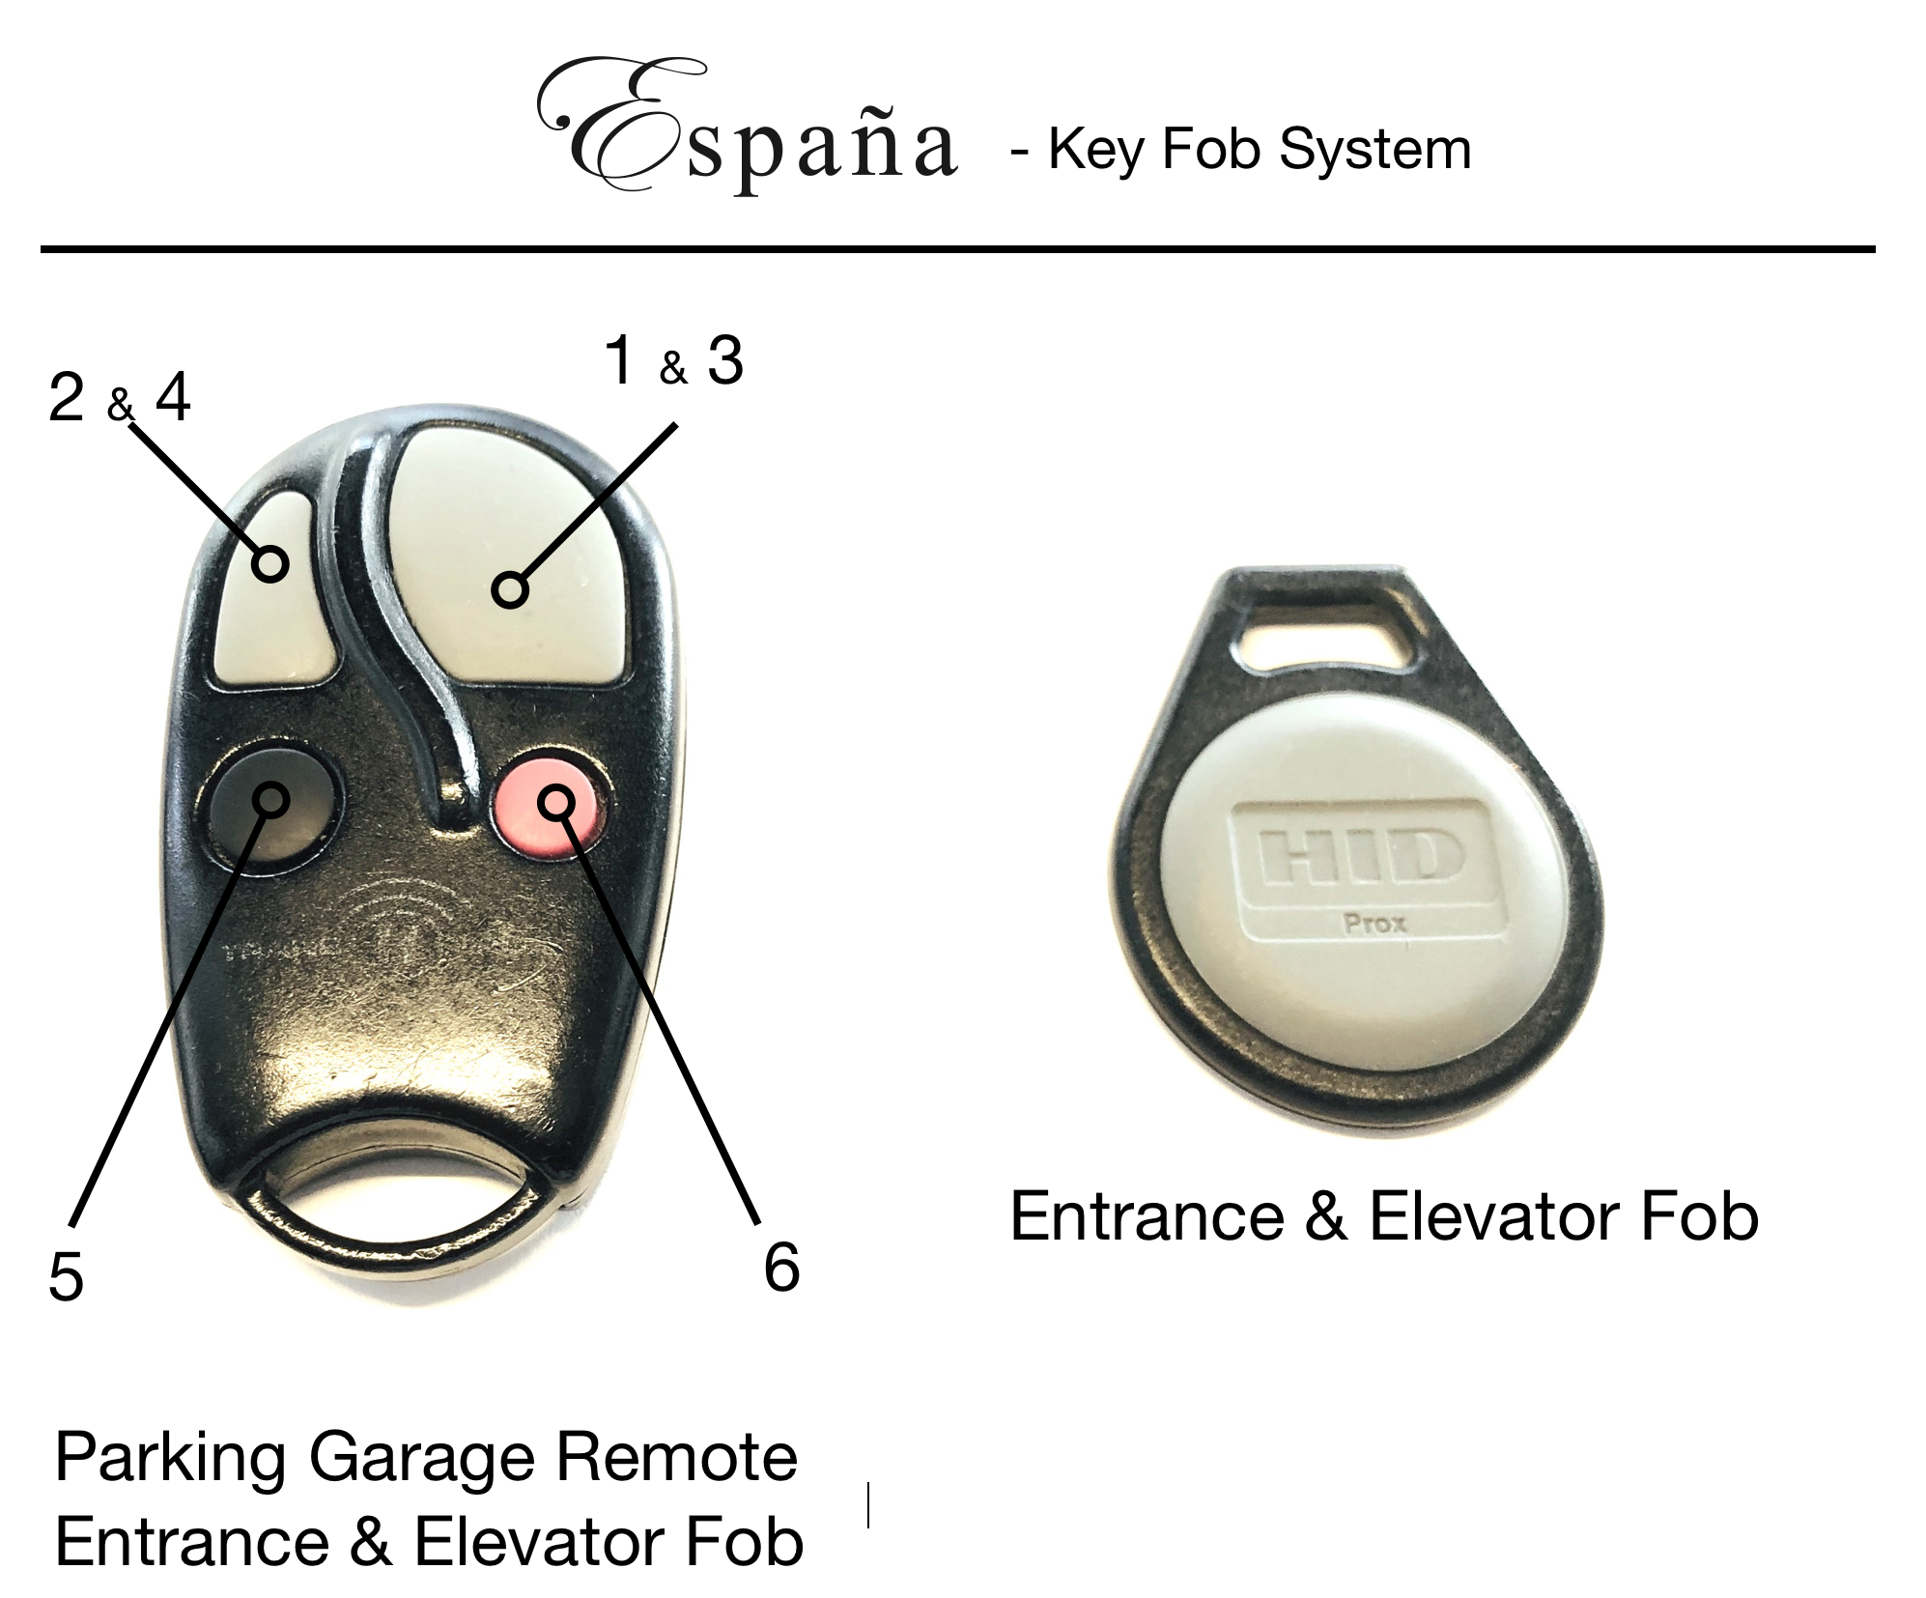

Parking Garage Remote - Is also an Entrance & Elevator Fob

Entrance & Elevator fob - can not open the garage door

ESPANA - Key Fob access points

Elevators
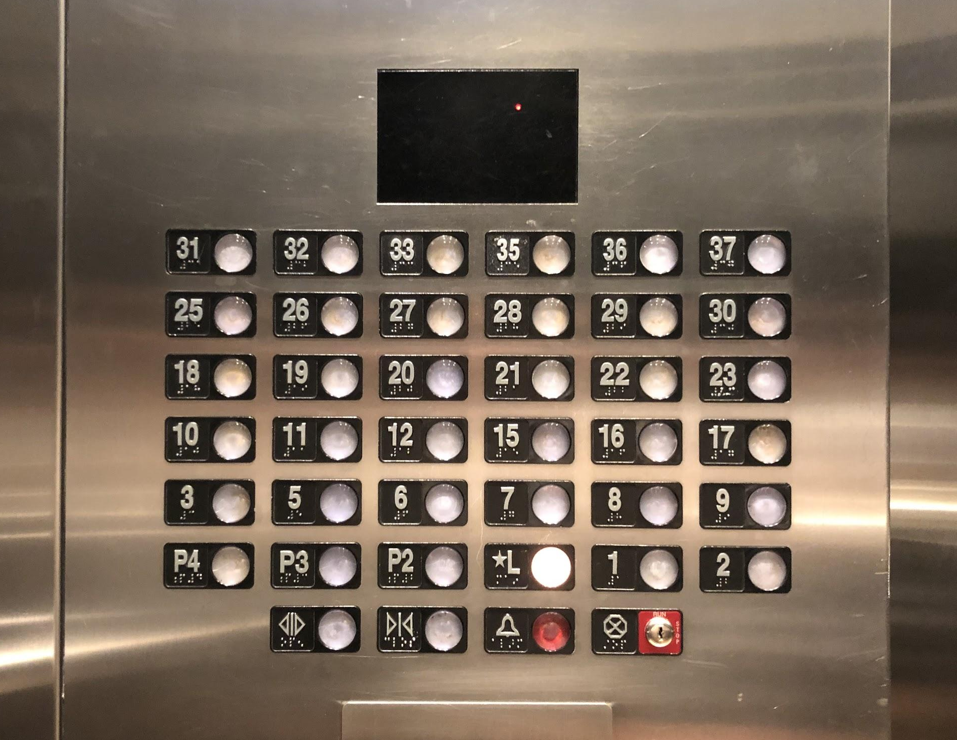

Front Entrance

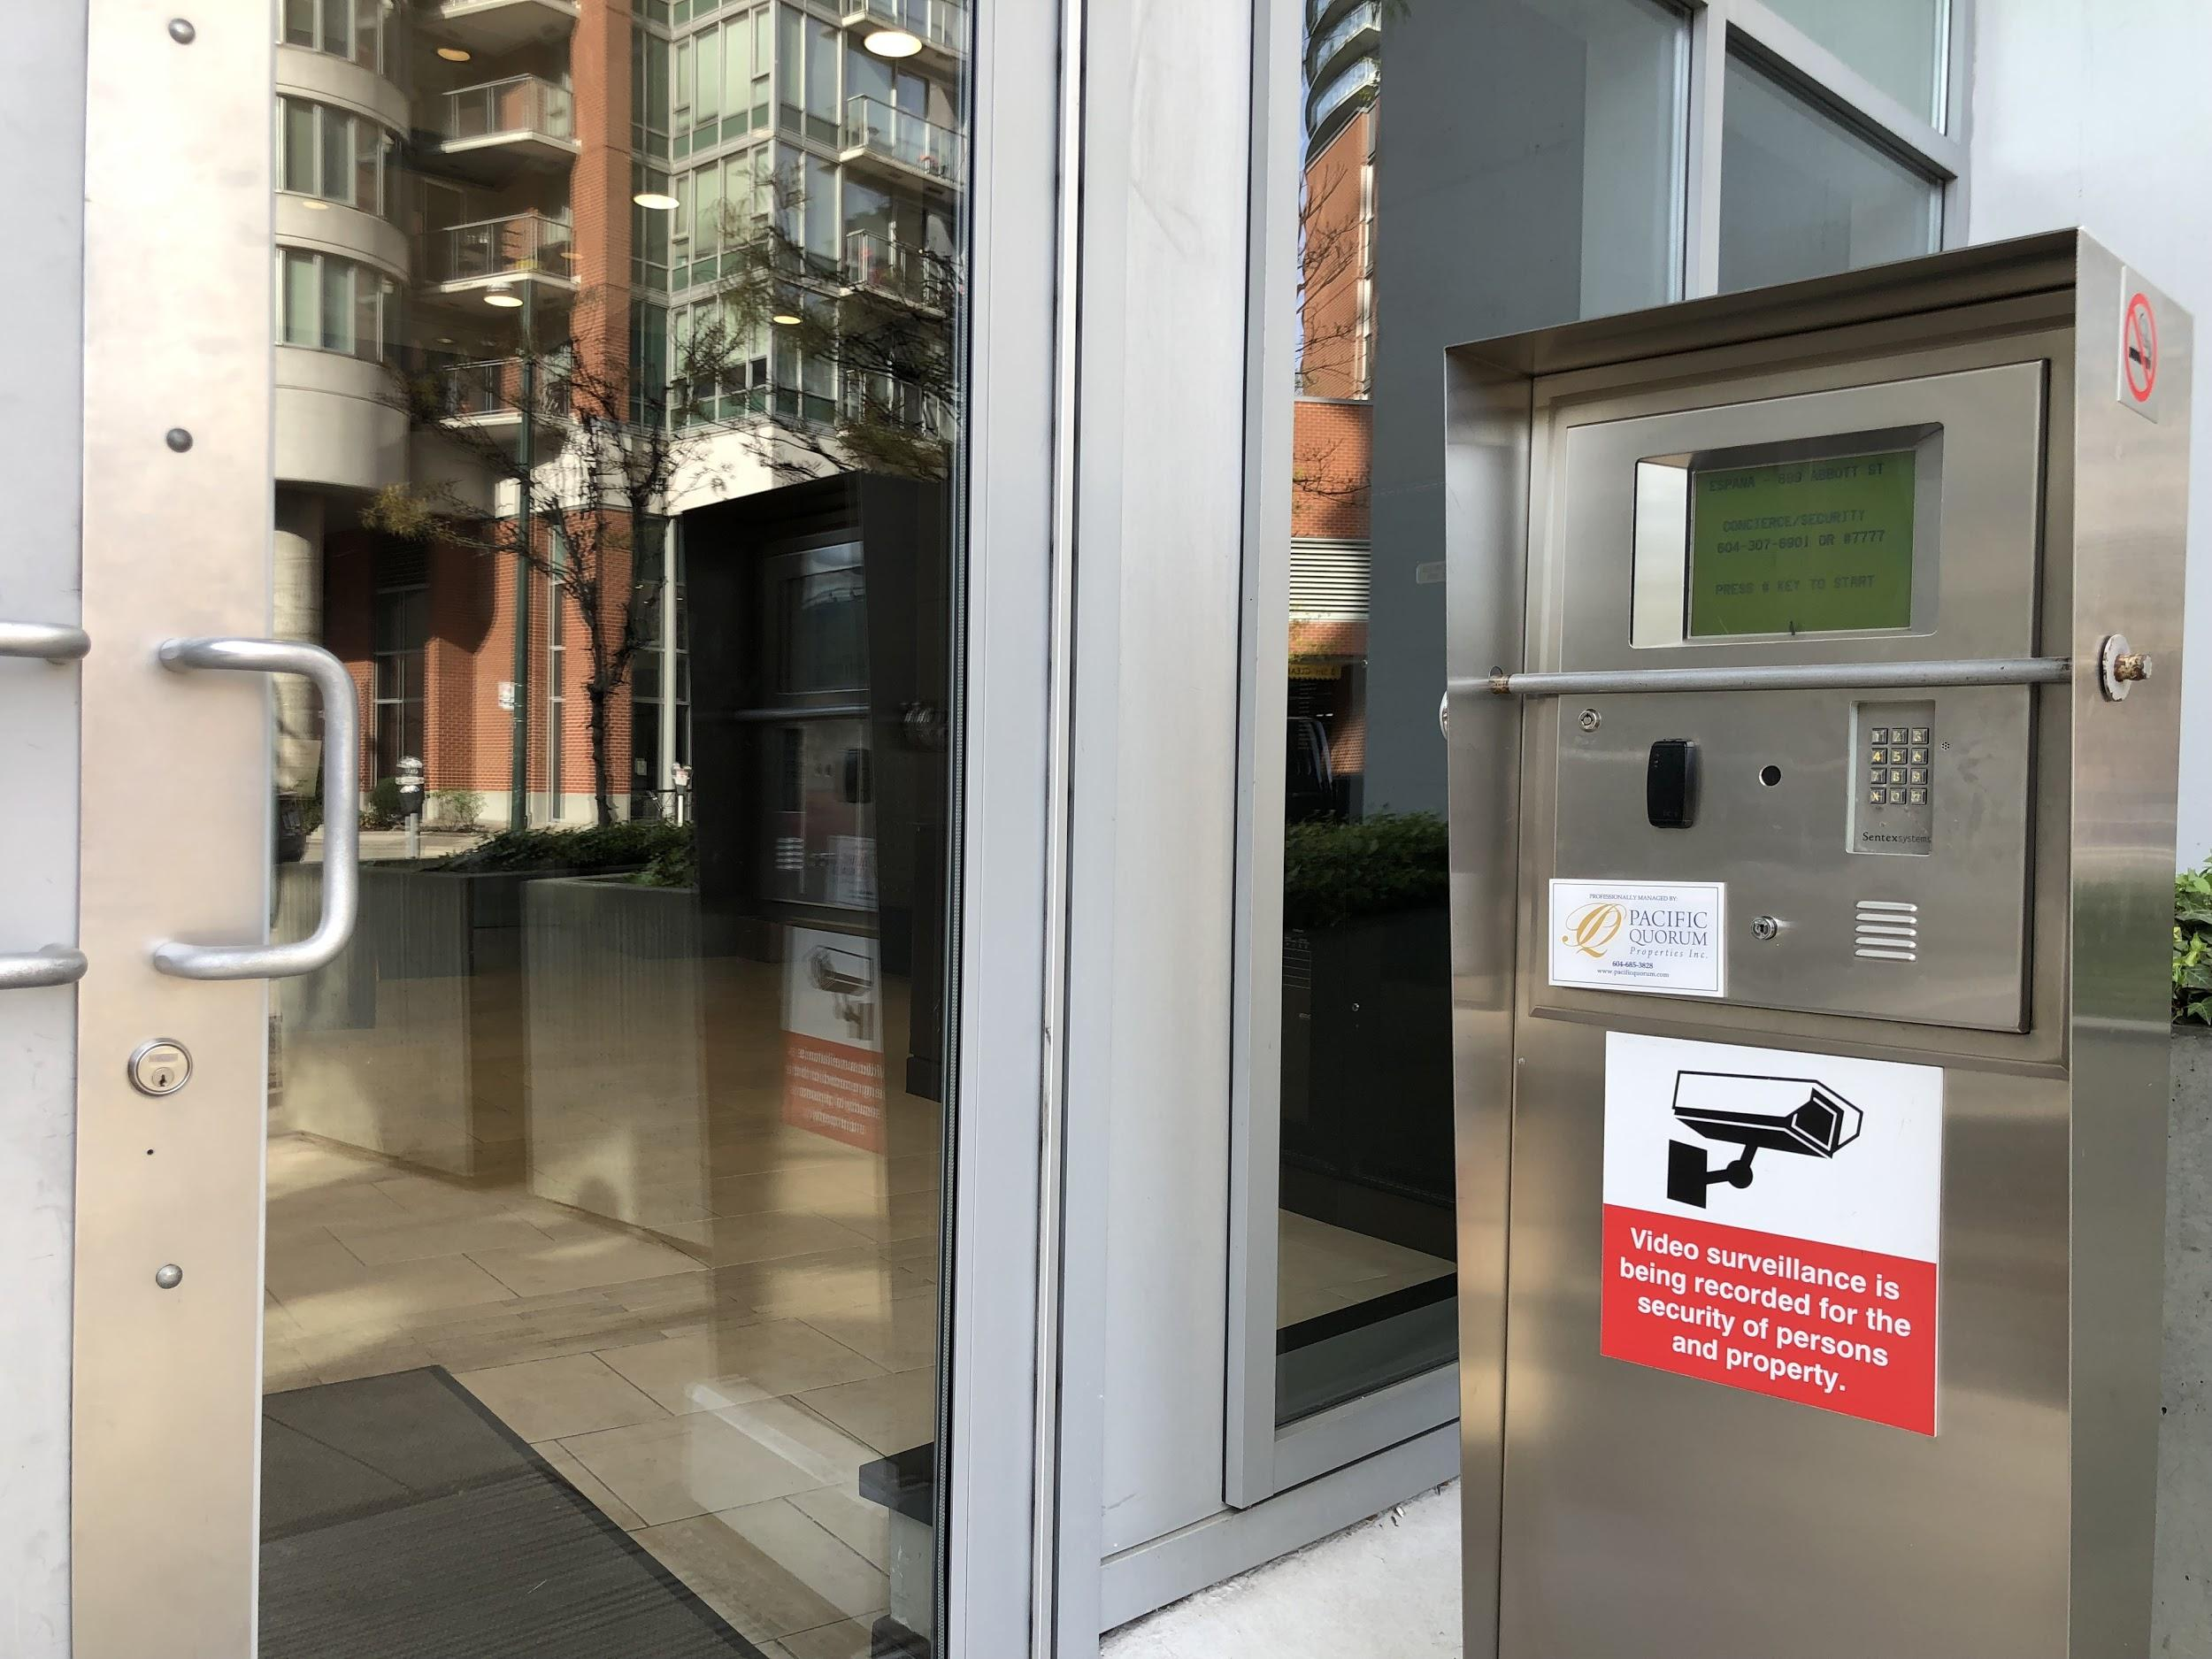
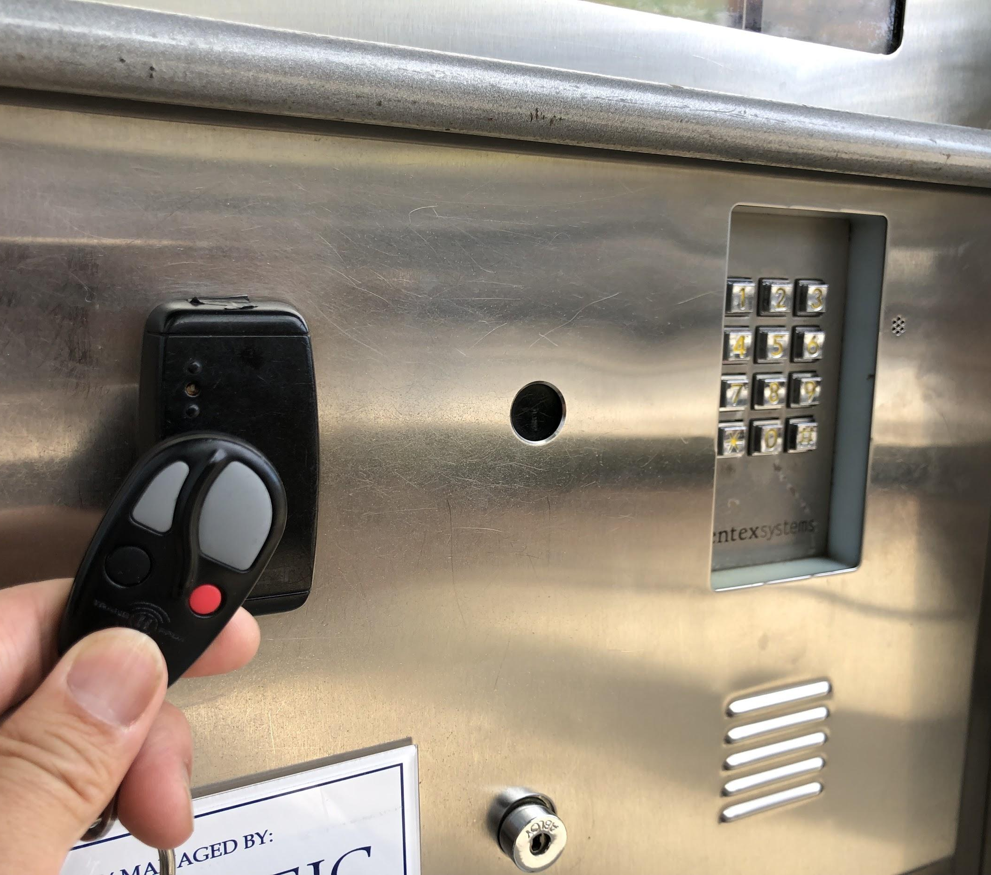

Garbage
Located at the Lobby level. As you exit the elevator, turn right, then turn immediately right again where you will find a set of doors. Enter through that door, walk straight and enter through the second set of doors. Once past the second set of doors there will be a door immediately on your right side. Enter those doors and follow the signs to the garbage room. You will need your key fob to enter the room.

Composting & Recycling

Vancouver is an environmentally friendly city. Please help us follow all recycling bylaws. These are the different categories of recycling we ask you to help us with:

- Composting: We have a bylaw requiring composting. Please compost all food scraps AND any paper that has been soiled with food (ie. Pizza boxes).
- Cans/Bottles (Returnable):
- Paper/Cardboard:
- Metal Cans/Plastic containers/Glass containers:

Should any materials be thrown away in the wrong bins a fine will be given. Please carefully follow the signs to prevent any sort of unnecessary fines.

Other tips on what to include

Transit
Taxis
Ride Sharing Services
Grocery / Stores Nearby
Favourite Restaurants
Things to Pack
Important local websites
Things to Book in Advance

